Smart Sea Wall Structural Manual:

This report was written to outline directions on how to assemble and construct the smart sea wall’s exterior housing. This process will require a variety of tools, including but not limited to:

* Hand Drill
* Upright Drill Press (Found in the wood shop)
* Dremel (Found in the woodshop)
* Screw drivers of various sizes
* Soldering Iron and Heat Gun
* Marine Calking (3M Marine Adhesive Sealant Fast Cure 4200 from West Marine)
* Calking Gun
* PPE: Face mask and Goggle

**Controller Box Setup Phase:**

1. First, make sure to order all items off the list in the Smart Sea Wall Budget 2 page on the “sensors and shopping list” excel sheet. You can find the form at this link: <https://docs.google.com/spreadsheets/d/1qX0Vki_mn7VooCTtaDtbQvvIgnxsV4J2/edit?usp=sharing&ouid=106877309547249609301&rtpof=true&sd=true>
2. Order the PCB board on JLC PCB (<https://jlcpcb.com/>) using the zip files called “gerbers.zip” on the attached GitHub repository: <https://github.com/CrystalCoasts/pcb-files>
3. After the PCB arrives and the parts, start soldering everything onto the board. The board must look like this afterwards:

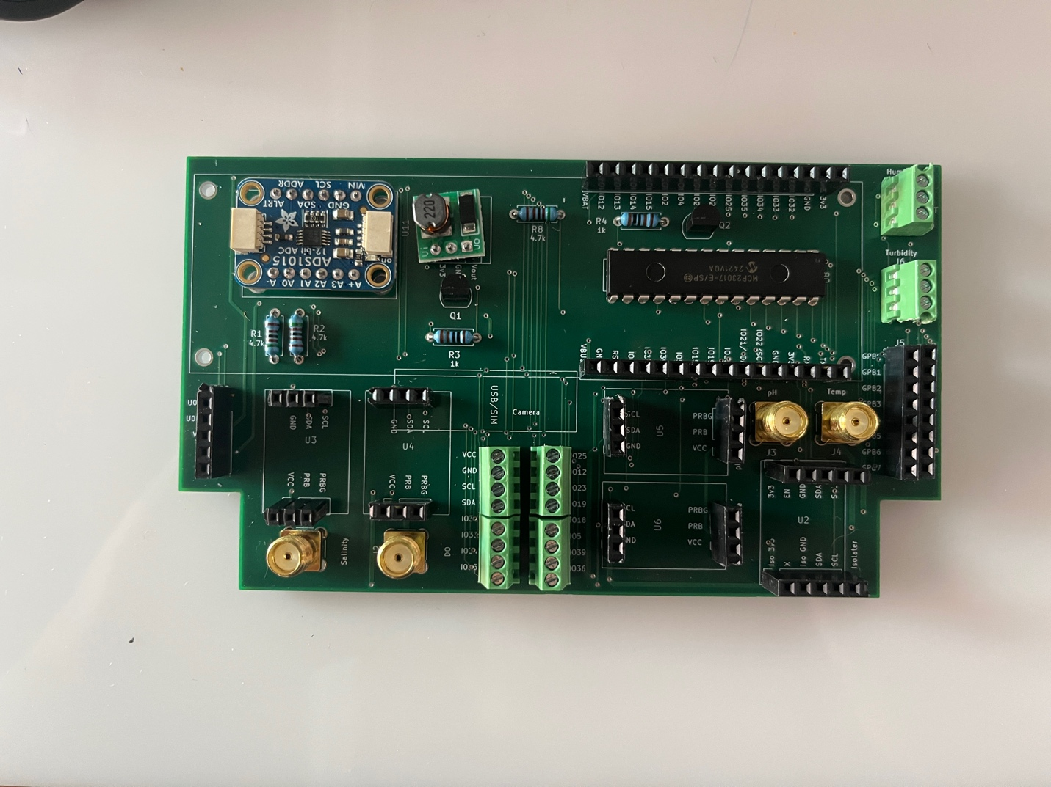

Some steps and materials are also outlined in the “pcb-files” GitHub repository.

1. Plug all sensor components into the PCB like such: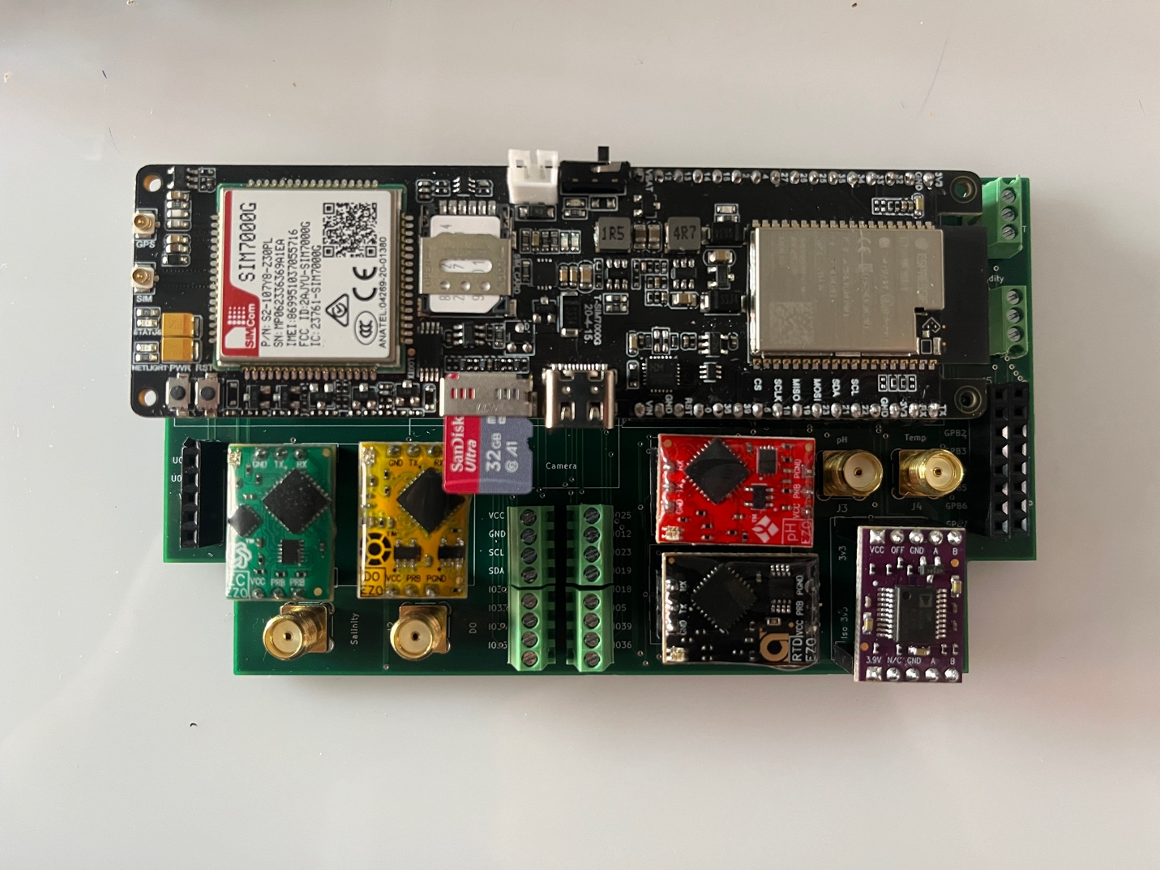

**(All the atlas sensors must be facing the correct direction. GND, TX, and RX should be on the opposite side of the SMA connector, while VCC, PRB, and PGND are on the side of the SMA connector.)**

1. Connect the extension cables corresponding to each sensor to its assigned SMA connector. (Each SMA is labeled on the PCB, and each cable is color coated. Please view closely and **DO NOT** mix them up).
2. **Humidity and Turbidity Sensors** can be screwed directly into their terminal ports, matching the connections as directed on the PCB. **Please cut (6) 2 meter wires turbidity and humidity, followed by another (6) 3 meter wires as to allow for modular connection with the junction box.**
3. Using the purchased **RS232 Data Cable**, screw wires into the screw terminal and connect them to the following cables connection on the camera:

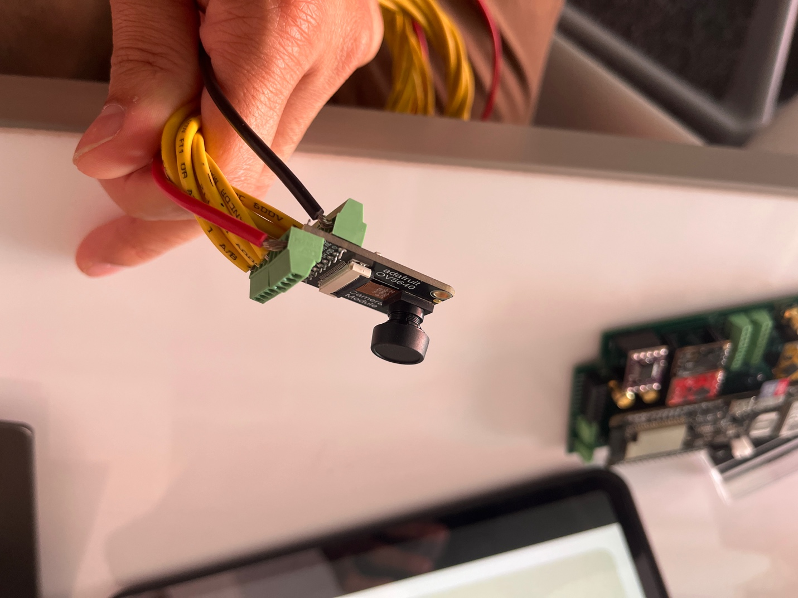

* PWDN_GPIO_NUM   =   NOT CONNECTED
* RESET_GPIO_NUM   = NOT CONNECTED
* XCLK_GPIO_NUM     = NOT CONNECTED
* SDA_GPIO_NUM     = GPIO 21
* SCL_GPIO_NUM     = GPIO 22
* D9_GPIO_NUM       = GPIO 23
* D8_GPIO_NUM       = GPIO 19
* D7_GPIO_NUM       = GPIO 18
* D6_GPIO_NUM       = GPIO 5
* D5_GPIO_NUM       = GPIO 39
* D4_GPIO_NUM       = GPIO 36
* D3_GPIO_NUM       = GPIO 26
* D2_GPIO_NUM       = GPIO 27
* VSYNC_GPIO_NUM     = GPIO 34
* HREF_GPIO_NUM     = GPIO 35
* PCLK_GPIO_NUM     = GPIO 25
* There may be another cable attached from the GPIO extender to PD and RT if you may desire to do so. Doing so may allow the camera to save power by turning it off.

1. The antenna may be attached through the purchased SMA to UCL and SMA to N Male adapter from the boat antenna.
2. The battery may be connected via USB C to USB C, the cable is the 90 degree connector stated in the BOM.
3. The solar panel may be connected to the battery through the included connector that allows wires to be connected to the battery. Follow the biasing stated on the connector.

**You have finished connecting all the wirings for the interior of the Controller Box!!**

**Exterior Box Assembly:**

After ordering all the items off the BOM/Budget, the following boxes will arrive:

* Controller Box: <https://www.polycase.com/zq-060404>
* Sensor Box: <https://www.polycase.com/ml-47f>
* Wiring Box: [https://www.polycase.com/ml-24f#ML-24F*1508](https://www.polycase.com/ml-24f#ML-24F*1508)

Additionally, the following Cord grips will arrive:

|  |  |
| --- | --- |
| <https://www.mcmaster.com/7310K54/> | Salinity Fittings |
| <https://www.mcmaster.com/7310K55/> | pH Fittings |
| <https://www.mcmaster.com/7310K34/> | Disolved Oxygen Fittings |
| <https://www.mcmaster.com/7310K52/> | Temperature Fittings |
| <https://www.mcmaster.com/7310K54/> | Cable grips for modular connection of sensors (4) |
| https://www.mcmaster.com/7310K53/ | Cable grips for solar and antenna (1) |
| <https://www.mcmaster.com/7310K51/> | Cord Fitting (2) |

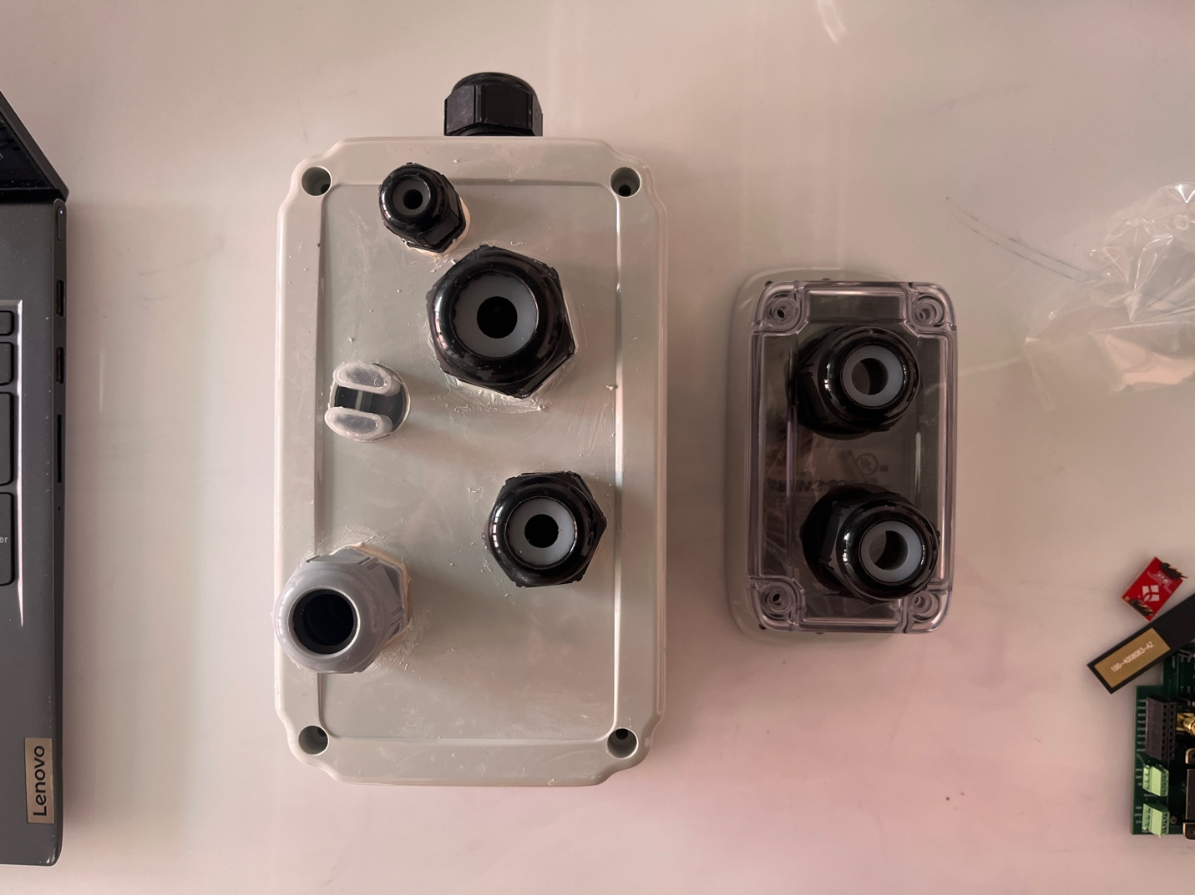

1. Drill these holes according to the sizes of the sensors and the cord grips. The sizes are given on the table above. A hole must be drilled for the turbidity sensor since it is too big to be used with a grip.
   1. Use a hand drill first to drill the holes. Start with a small diameter bit, working your way up to the biggest bit.
   2. After drilling to the highest bit with the hand drill, use the upright drill press to drill bigger holes as it takes bigger drill bits.
   3. If the hole still needs to be bigger, find the Dremel and attach a sanding band. Burn the hole to the correct size.
2. After drilling the appropriately sized holes, use the calking gun to seal the holes with the cord grips.

**Wiring Setup:**

1. Bunch all the SMA cables, and the turbidity and humidity wires together.
2. Use the heat shrink cabling to bunch them together.
3. Wire them from the **Controller box** to the **Wiring box**
4. Use cable connects to connect the regular wiring (humidity and turbidity), and screw the probe cables to the extension cables (or if needed, attach more extension cables if the sensing box is too far away)
5. Wire the sensor wiring to the **Sensing box**.
6. Screw the sensing probes into the cable grips on the top of the sensing box. (In this step you may need to attach the extension SMA cables to the probes)
7. Bunch the Antenna and Solar Panel wires together and heat shrink them for about 1 meter. Wire them through the other cord grip in the **Controller Box**. (**You may need to also bunch the camera wires together if using a camera)**

**Camera Setup:**

1. Attach wiring to the camera as per the steps above.
2. Run the wires with the antenna and solar panel
3. Drill a hole in the camera box and attach a cord grip for it with calking:
   1. Camera box: <https://www.digikey.com/en/products/detail/hammond-manufacturing/1555B2GY/2359933>
   2. Cable fittings: <https://www.mcmaster.com/7310K52/>
4. Cut off the front side of the box and calk on acrylic see-through panel.